**BMI Calculator Coding Challenge Project Documentation**

**INTRODCUTION :**

**In BMI Calculator Coding Challenge we need to calculate BMI based on the Formula :** BMI(kg/m) = mass(kg) / height(m)

In the Next Step need to predict number of persons who belongs to Overweight Category

Finally need to build test and Automate the Code.

**FRAMEWORKS AND VERSION USED :**

1. **Pycharm Community Version**
2. **Python V3**

**LIBRARIES USED :**

1. **Pandas**
2. **Numpy**
3. **Pyinstaller**
4. **Pytest**

**PROJECT APPROACH CODE, IMPLEMENTATION AND SAMPLE TEST CASES:**

In this particular problem we have given input as a **json Data**

I have implemented this problem in 2 approaches:

**Approach-1:** To fetch **Data from json file** and display the output BMI, BMI Category and Health risk, Count of the Overweight people in the given Dataset.

**Approcah-2:** To Accept **Height and Weight parameters from the user** and display theoutput BMI, BMI Category and Health risk, Count of the Overweight people in the given Dataset.

**Approach -1:**

Step-1: In this approach user need to give the path of the json file as shown inn below snippet

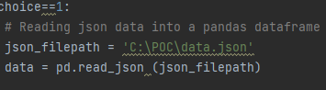

Step-2: Data is been read into the data frame and passed into the calulateBMI function which will convert the Height into kilograms and returns the BMI using formula as shown in below snippet :

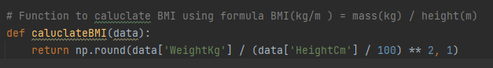

**Step-3:** In this Step different ranges of BMI values will be assigned to the variable as mentioned in the Problem Statement and two lists have been created for storing different BMI Categories and Health risk.

**Step-4:**  In this Step BMI will be mapped with the respective BMI Categories and Health risk using np.select() function and BMI table with 3Columns will be displayed

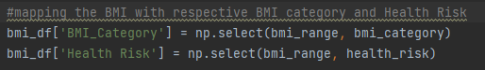

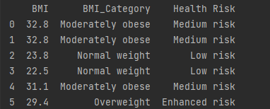

**Step-5:** In this step we will calculate the number of Overweight persons using len() function and equals operator





**APPROACH-2 :**

In this approach user needs to enter the Height(in cms) and Weight from the console as shown in below snippet , it will asks for the number of entries you want to enter

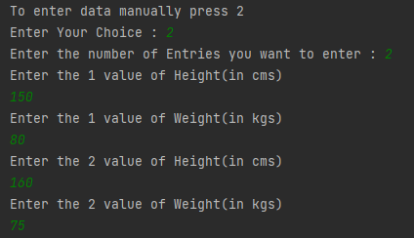

**Step-1:** These values will be passed into calculateBMI function and it will return the BMI value

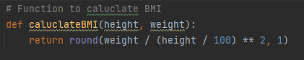

**Step-2:** In this step the BMI value from Step-1 will be passed to the getHealthStatus function to fetch the BMI Category and Health risk value for given BMI Value.

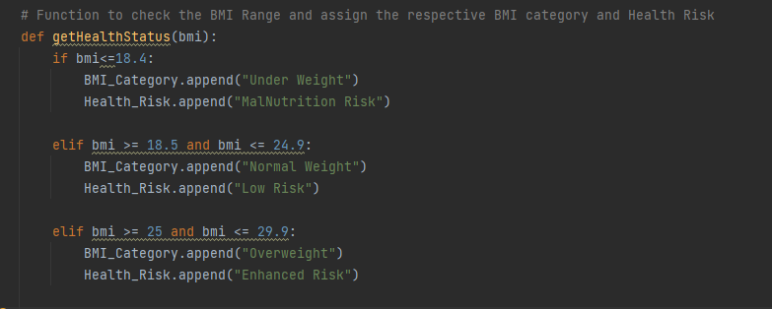

**Step-3:** In the final step BMI Table with 3colums will be displayed and also number of Overweight people count will be returned as shown in below snippet:

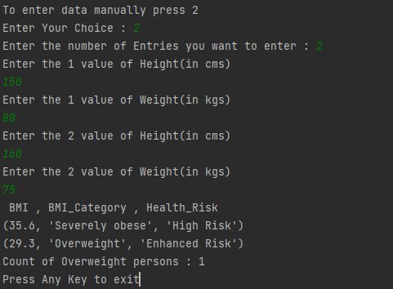

**CONCLUSION :**

**Code has been tested with different set of test cases and worked properly in all the scenarios. And Build into .exe Executable.**

**Important File Names :**

**main.py – Main Code file**

**main.exe – Executable file**

**BMI Caluclator Word Document – Project Documentation**

**requirements.txt – Configuration files**